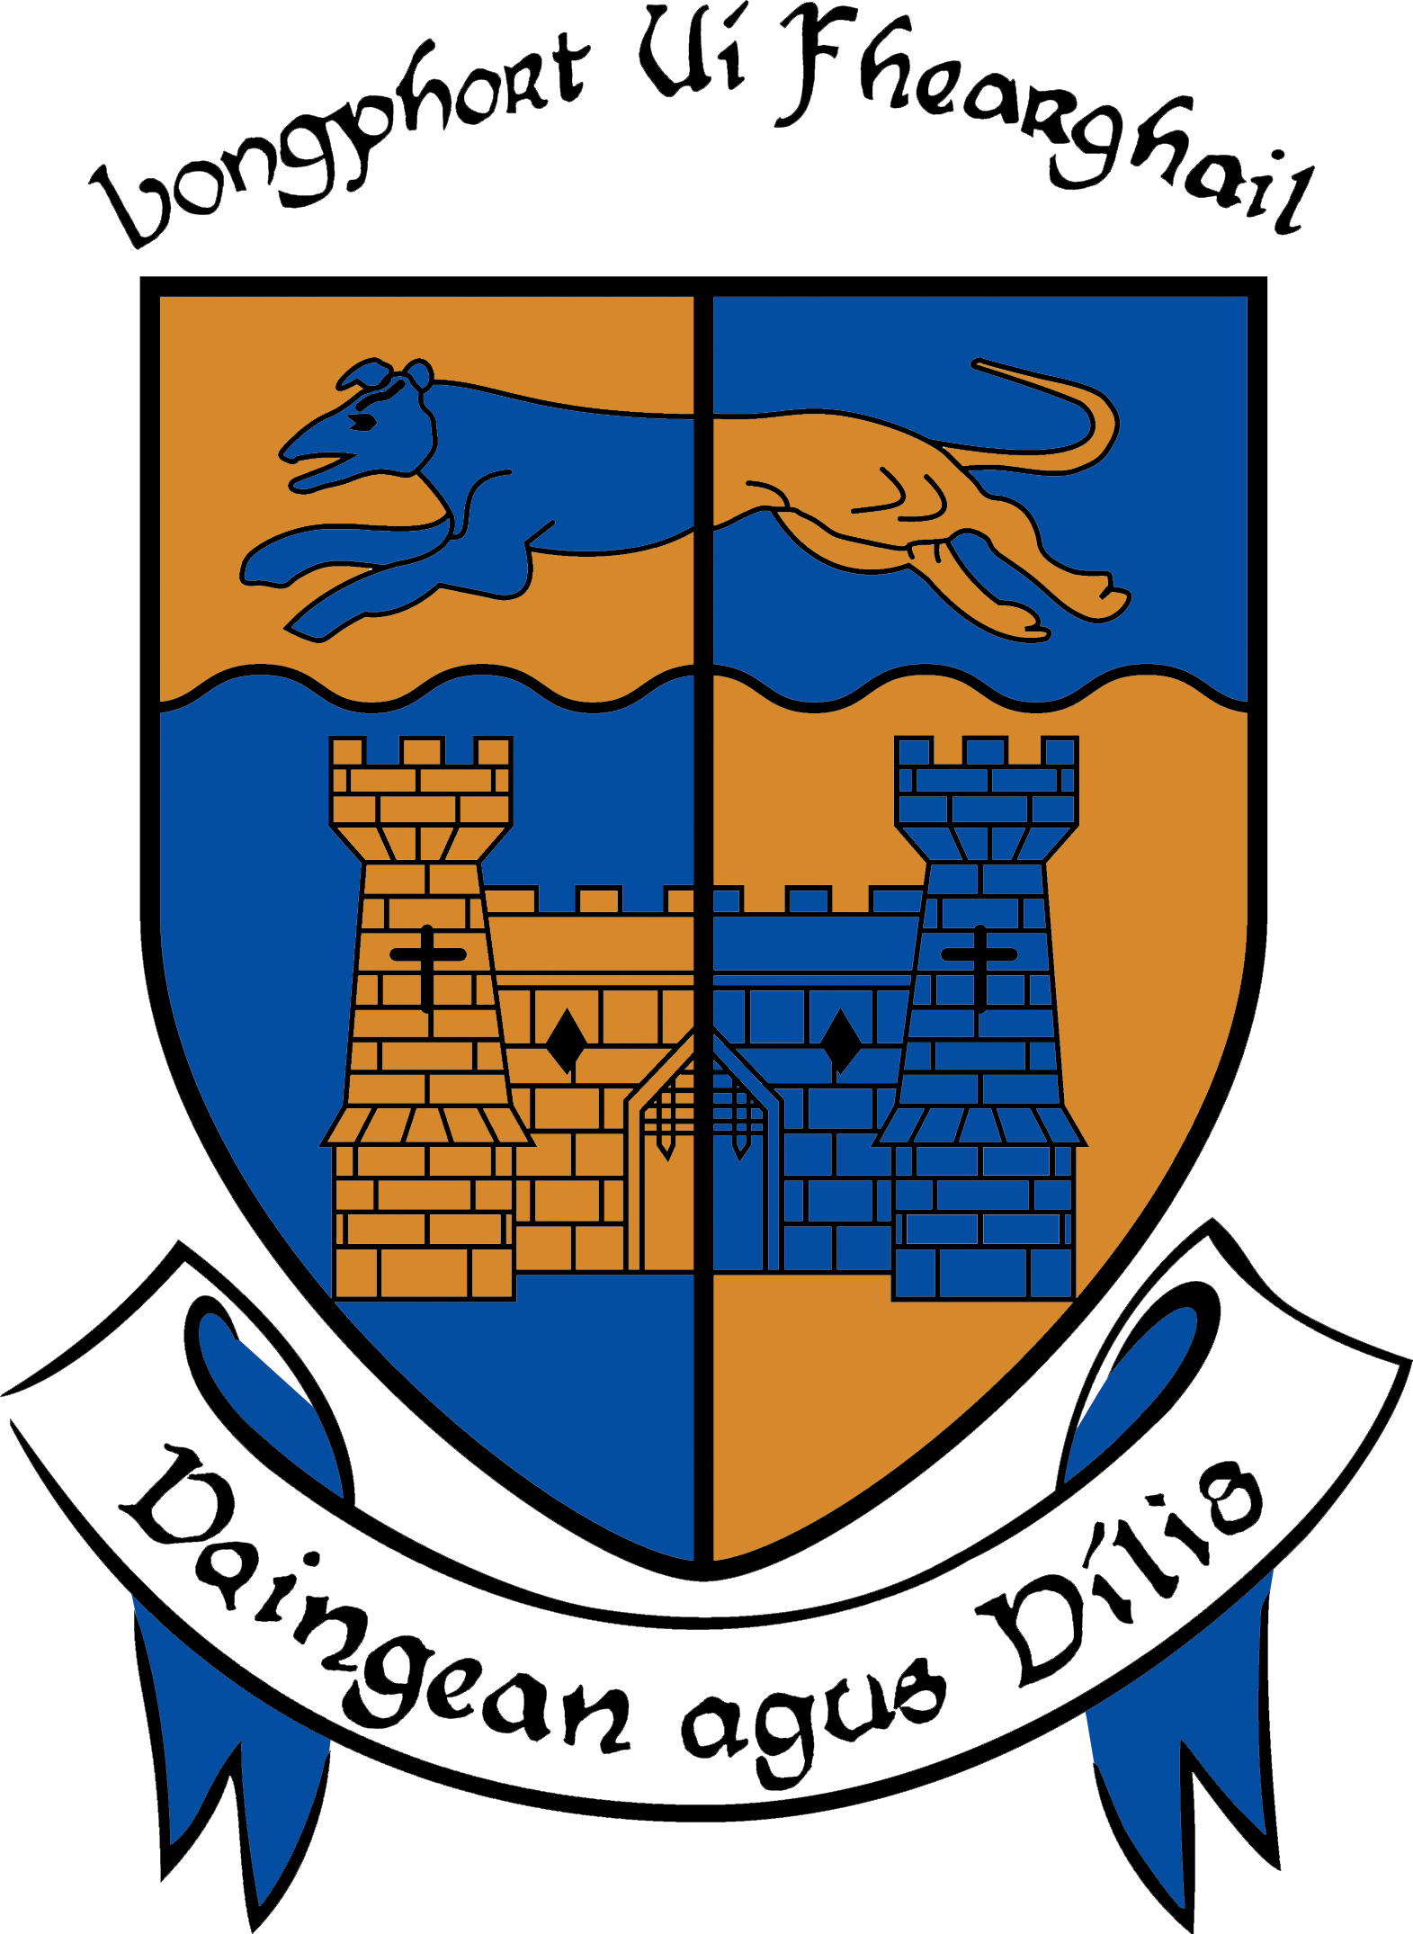

LONGFORD COUNTY COUNCIL

COMHAIRLE CHONTAE LONGFOIRT

Minutes of February Monthly Meeting of Longford County Council
held in the Council Chamber, Aras an Chontae, Great Water Street, Longford on
Wednesday, 19th February 2014 at 4.00 p.m.

PRESIDING: Councillor Larry Bannon, Mayor.

MEMBERS PRESENT: Councillors – Gearoid O Bradaigh, John Browne,
Mick Cahill, Micheál Carrigy, Mark Casey,
Paul Connell, John Duffy, Sean Farrell Frank Kilbride, Donncha Mac Gleannáin, Victor Kiernan,
Padraig Loughrey, Luie McEntire, Colm Murray, Peggy Nolan, P.J Reilly, Mae Sexton, Barney Steele and Thomas Victory.

IN ATTENDANCE: Mr. Tim Caffrey, County Manager.
Mr. Barry Lynch, Head of Finance/Director of Services.
Mr. Tom Murtagh, Acting Director of Services.
Mr. Ciaran Murphy, Acting Director of Services.

APOLOGY: Councillor Martin Mulleady,

MEETINGS
ADMINISTRATOR: Ms. Anne Lee

VOTES OF SYMPATHY.

On the proposal of Mayor L. Bannon seconded by Councillor F. Kilbride, it was unanimously resolved that a vote of sympathy be extended to the Killeen family on the death of their father, Michael, retired County Manager.

On the proposal of Councillor S. Farrell seconded by Mayor L. Bannon, it was unanimously resolved that a vote of sympathy be extended to the Donlon family, Derryhaun, Kenagh, on the death of John, former member of Longford County Council.

Mayor Bannon and the members of the Council spoke regarding Michael Killeen’s contribution to public life in County Longford.

The Mayor and members also spoke regarding John Donlon’s work as a County Councillor and his achievements on the football teams of 1966 and 1968.

All members of the Council associated themselves with the votes of sympathy and many tributes were paid to Michael and John.

Mr. T. Caffrey, County Manager, on his own behalf and on behalf of the staff of the County Council associated himself with the votes of sympathy. He stated that Michael Killeen had given twenty eight years outstanding service to the County.

A silent prayer was said for the deceased.

It was agreed that the Adjourned Meeting take place on Thursday, 27th February 2014 at 3.00p.m.

This concluded the business of the meeting.

Signed: _______________
Anne Lee,
Meetings Administrator.

Confirmed and adopted at Monthly Meeting of Longford County Council held on the
19th March 2014.

Signed: _______________
Mayor.

